**St. Joseph Island Hunters & Anglers**

**Awesome Women’s Experience**

*A UNIQUE INTRODUCTION INTO THE OUTDOORS FOR WOMEN*

*Spend a day in the company of like-minded women*

*Highly skilled instructors offering special experiences and education*

*Continental Breakfast, Lunch & Supper provided*

*Silent Auction*

*Registrations open 8 am. Morning classes 8:30am - noon, Afternoon classes 1-4:30 pm*

OPen to Women 12 years and older. under 16 years old **must** be

accompanied **and** supervised by an adult.

Choose from the following choices

**Morning**

**Game Camera tips**

**Archery**

**Afternoon**

**Astronomy**

**Tomahawk Throwing**

**Cost: $90.00 ST. JOSEPH ISLAND HUNTERS & ANGLERS members**

**$100.00 non members**

**rEGISTer BY August 1, 2017**

**classes filled on first come/first served basis \*\****Early Bird registration gifts*

REGISTRATION FORMS CAN BE downloaded on the

ST. JOSEPH ISLAND HUNTERS & ANGLERS WEBSITE

Cheques payable to SJI Hunters & Anglers

Mail to: Sigrid Robinson

RR 1

Hilton Beach Ont.

P0R 1G0

For further information contact:

Teresa Caughill 705-246-2581

Sigrid Robinson 705-246-0923

Carmen Nelson 705-971-5040

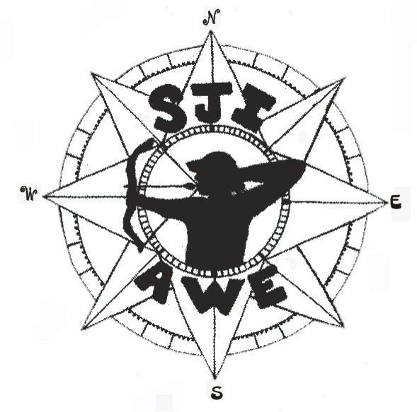

Saturday, September 9, 2017

**St. Joseph Island Conservation Centre**