**St. Joseph Island Hunters & Anglers**

**Awesome Women’s Experience**

*When was the LAST time you did something for the FIRST TIME?*

*A UNIQUE INTRODUCTION INTO THE OUTDOORS FOR WOMEN*

*Spend a day in the company of like-minded women*

*Highly skilled instructors offering special experiences and education*

*Continental Breakfast, Lunch & Supper provided*

*Registrations open 8 am. Classes 8:30am - noon, Afternoon classes 1-4:30 pm*

OPen to Women 12 years and older. under 16 years old **must** be

accompanied **and** supervised by an adult.

**We have changed our format. all participants will have**

**equal time to enjoy the following classes.**

**tomahawk throwing**

**forestry and wildlife management**

**compass quest scavenger**

**flyfishing**

**Cost: $90.00 ST. JOSEPH ISLAND HUNTERS & ANGLERS members**

**$100.00 non-members**

**rEGISTer BY September 10, 2018**

**Registrations filled on first come/first served basis**

**\*\****Early Bird registration gifts*

REGISTRATION FORMS CAN BE downloaded on the

ST. JOSEPH ISLAND HUNTERS & ANGLERS WEBSITE

Cheques payable to SJI Hunters & Anglers

Mail to: Sigrid Robinson

RR 1

Hilton Beach Ont.

P0R 1G0

For further information contact:

Teresa Caughill 705-246-2581

Sigrid Robinson 705-246-0923

Carmen Nelson 705-971-5040

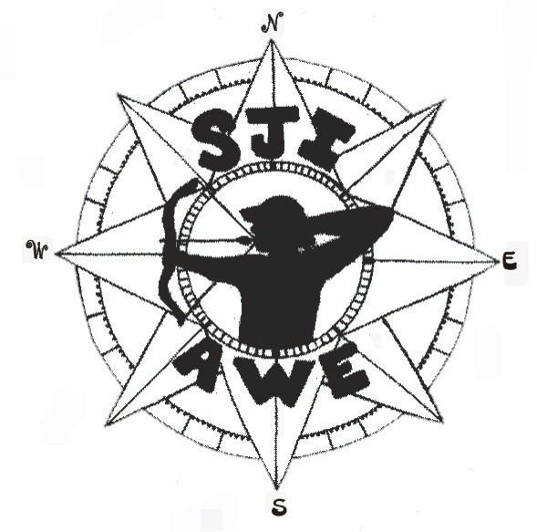

Saturday, Oct 20, 2018

**St. Joseph Island Conservation Centre**